During the **week of April 16-20**, the Wisconsin Bankers Association (WBA) encouraged Wisconsin banks to celebrate commitment to the communities they serve with the second annual “***Power of Community***” week. The goal of the week was to bring together the efforts of the Wisconsin banking industry to show our collective impact and involvement in the state.

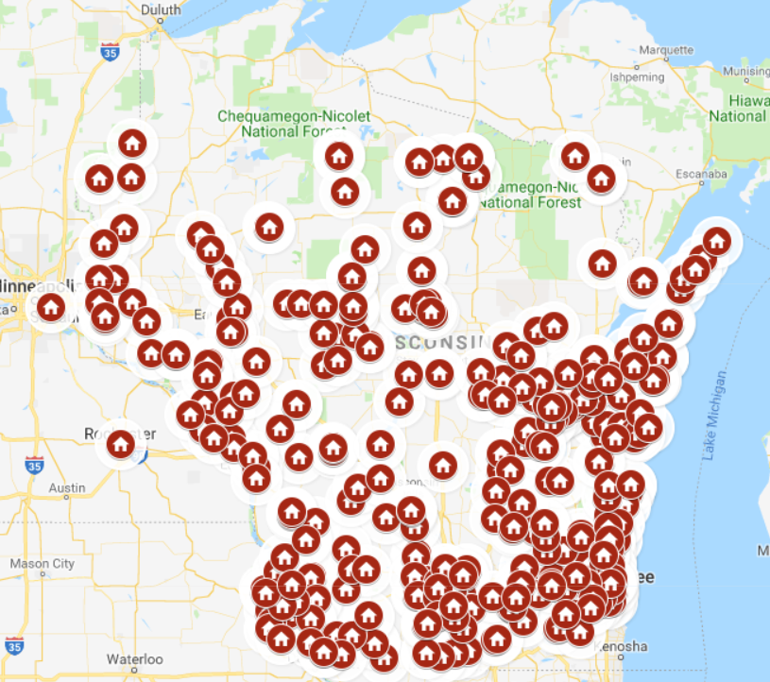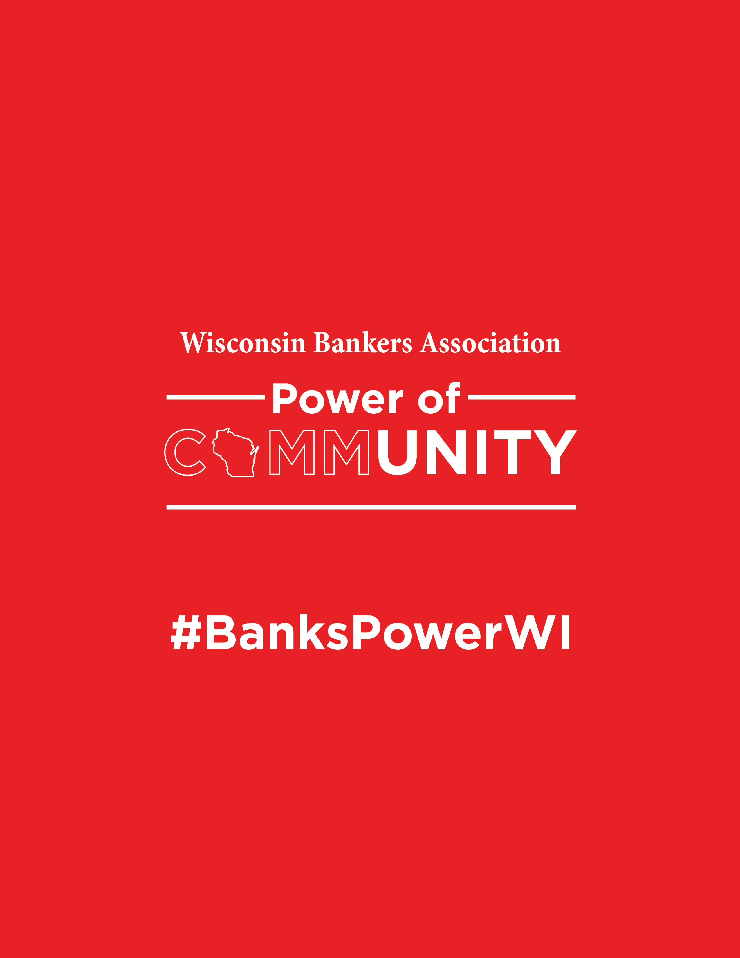

**Across Wisconsin…**

**90+ Banks** Participated in **400+ Locations** Around the State

**2,700+ Bankers** Volunteered

**4,000+ Hours** Spent Volunteering

**THANK YOU FOR BEING A PART OF IT!!**



[INSERT PHOTOS & RECAPS OF WHAT YOUR BANK DID FOR POWER OF COMMUNITY]

**[INSERT BANK LOGO]**