PANDEMIC INFLUENZA MODEL PLAN

For use as a stand-alone plan or as a component to a financial institution’s disaster recovery/business continuity plan.

TABLE OF CONTENTS

Introduction Page 1

The Potential Impact of the Pandemic Influenza Page 2

FFIEC Requirements for Financial Institutions Page 5

Model Plan Page 6
INTRODUCTION

Influenza pandemics in general have occurred for centuries with three occurring in the 20th century alone, in the years 1918, 1957, and 1968. The first influenza pandemic declared in the 21st century occurred in June 2009 with the H1N1 outbreak. On January 30, 2020 the World Health Organization (WHO) declared the COVID-19 outbreak a “public health emergency of international concern” and on March 11, 2020, WHO declared COVID-19 a pandemic. Consequently, careful planning for any business disruption is imperative.

By way of background, in anticipation of a global pandemic outbreak of the avian flu (H5N1), on November 1, 2005, the White House issued the National Strategy for Pandemic Influenza, which discusses the threat and potential impact of a pandemic influenza event. It also identifies the roles and responsibilities for the federal government, the private sector, and others. The Strategy was last updated in 2017.

This WBA Pandemic Influenza Model Plan (Plan) was first prepared in 2007 to deal with the then-current threat of an outbreak of avian flu in Asia. The Model has been updated to include certain aspects of the March 2020 FFIEC guidance on pandemic planning and to reflect the now global pandemic outbreak of the new coronavirus disease 2019 (COVID-19) virus. According to WHO, COVID-19 cases in the U.S. include: imported cases in travelers, cases among close contacts of a known case, and community-acquired cases where the source of infection is unknown. As you will see on the next page, COVID-19 has now spread globally.

While no business should ignore the possible outbreak of an influenza pandemic, or other similar disasters, financial institutions in particular are required by federal banking regulators to plan for such a business interruption.

The Wisconsin Bankers Association (WBA) has prepared this Plan for use by financial institutions to aid them in complying with the requirements of federal regulators to prepare for a pandemic or a similar threat. The Plan is designed to be used as its own or as part of your institution’s broader disaster recovery plan.

The Plan is intended as a model only and must be customized by each financial institution to their specific situation prior to its implementation and use. Since it is a model only, it may not address every aspect of possible business disruption that could be affected by an outbreak at your particular financial institution. There is a list of “Additional Resources” with this Plan that financial institutions are encouraged to review for supplemental help in preparing their particular plan.
THE POTENTIAL IMPACT OF THE PANDEMIC INFLUENZA

A flu pandemic occurs when a new influenza virus emerges for which people have little or no immunity, and for which there is no vaccine. The disease spreads easily person-to-person, causes serious illness, and can sweep across the country and around the world in a very short time.

While it is difficult to predict when an influenza pandemic will occur or how severe it will be, on March 11, 2020, WHO declared COVID-19 a pandemic.

The epicenter of the COVID-19 outbreak was in Wuhan, Hubei Providence, China with some link to a large seafood and live animal market. Later, as a growing number of patients had no exposure to animal markets, person-to-person spread of the virus occurred. As of March 2020, person-to-person spread of the virus has been reported in many countries, including the United States. See the graph below of the number of COVID-19 cases States have reported to the Center of Disease and Control Prevention (CDC). As of January 21, 2020, State and local public health departments are testing and reporting their own cases. Wisconsin’s Department of Health Services (DHS) COVID-19 case information is also provided.

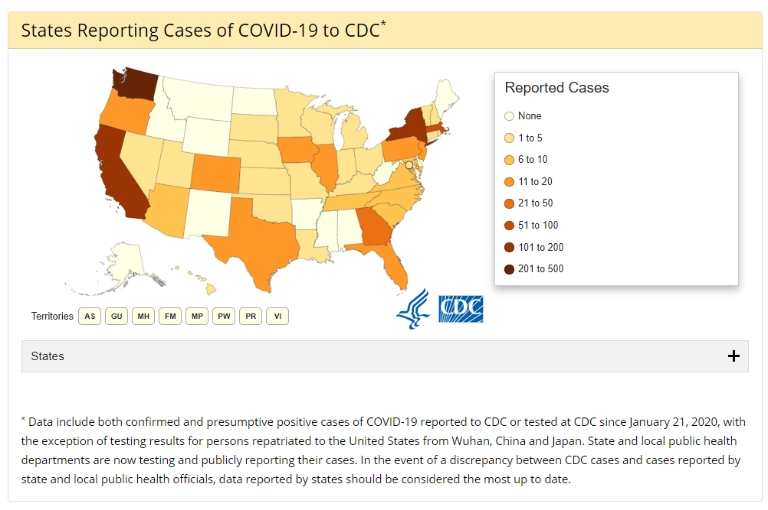

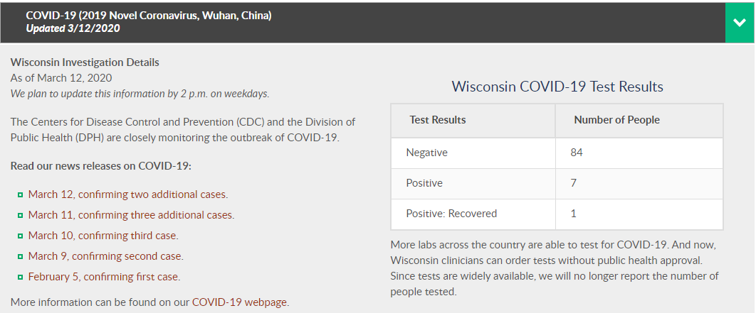

In general, wherever and whenever a pandemic starts, everyone around the world is at risk. Countries might, through measures such as border closures and travel restrictions, delay arrival of the virus, but they cannot stop it. As of the date of this document, several countries have restricted travel or have invoked border closures due to the COVID-19 virus. In the US, many municipalities have cancelled events which draw large attendances, school districts have extended spring breaks and have gone to on-line only classrooms, and businesses have cancelled popular events, such as the NBA suspending its basketball season until further notice.

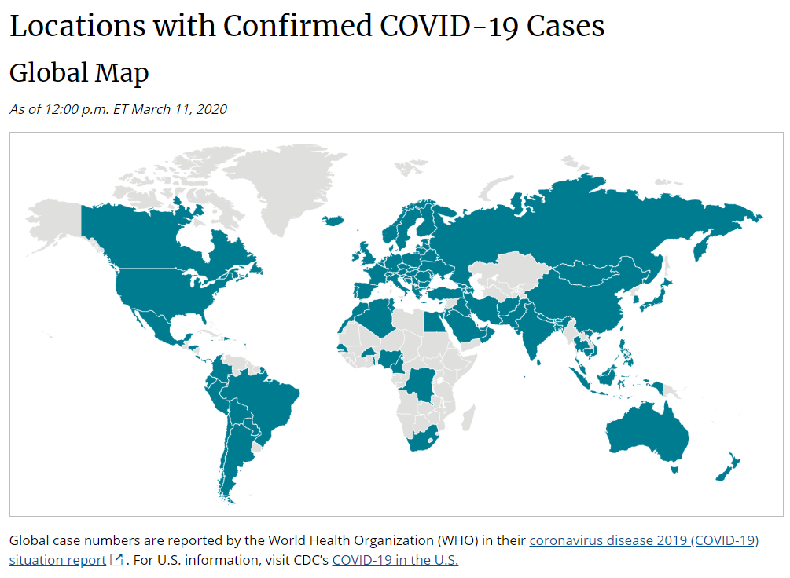
A few years ago, the Congressional Budget Office (CBO) made the following observations regarding the impact of an avian flu pandemic on the overall economy:

- An avian flu pandemic could be thought of as a shock to the economy, with both demand and supply-side effects in the short-run.
- The short-term effects of the pandemic would depend on its scope. Under the CBO’s severe scenario, the human toll would be devastating, and the economic effects would be greater than in recent recessions and roughly the same size as the average post-war recession. In a more moderate pandemic, the economic effects might not even be felt.
- In the long term, the economy’s response to natural disasters demonstrates that people can adapt to extreme hardship and businesses can find ways to work around obstructions. As a result, economic activity would recover, and the economy would eventually return to its previous trend growth rate.

These observations can certainly be seen today with the COVID-19 pandemic. To help mitigate the impact of COVID-19, the CDC released mitigation strategies for individuals, schools, assisted living facilities, workplaces, community and faith-based organizations, and healthcare settings and providers. The strategies include:

- Schools to implement social distancing measures of short-term dismissals for school and extracurricular activities or broader and/or longer-term school dismissals, either as a preventative measure or because of staff and/or student absenteeism.
- Workplaces to implement social distancing measures, limit large work-related gatherings, limit non-essential work travel, and encourage staff to telework (when feasible) or implement extended telework arrangements (when feasible) if the level of community transmission or impact of virus is substantial.
- Healthcare settings and providers to implement changes to visitor policies to further reduce exposures to health care providers, residents and patients, including limiting visitors to reduce facility-based transmission.

FFIEC REQUIREMENTS FOR FINANCIAL INSTITUTIONS

The Board of Governors of the Federal Reserve System, the Federal Deposit Insurance Corporation, the Office of the Comptroller of the Currency, and the Office of Thrift Supervision issued an interagency advisory to financial institutions and their technology service providers on March 15, 2006 regarding pandemic preparedness. In February 2008, the agencies issued supplemental guidance to remind financial institutions that business continuity plans (BCPs) should address the threat of a pandemic influenza outbreak and its potential impact on the delivery of critical financial services. In March 2020, the agencies issued guidance as an update to the previously issued guidance. Copies of all three interagency releases are included in the appendix to this model plan.

The guidance, issued in March 2020, identifies actions that financial institutions should take to minimize the potential effects of a pandemic. Specifically, the institution’s BCP should address pandemics and provide for a preventative program, a documented strategy scaled to the stages of a pandemic outbreak, a comprehensive framework to ensure the continuance of critical operations, a testing program, and an oversight program to ensure that the plan is reviewed and updated. The pandemic segment of the BCP must be sufficiently flexible to address a wide range of possible effects that could result from a pandemic, and also be reflective of the institution’s size, complexity and business activities.

All three interagency advisories discuss the National Strategy for Pandemic Influenza (National Strategy) and the roles and responsibilities it outlines for financial institutions.
Specifically, the National Strategy and interagency advisories set forth responsibilities of the U.S. private sector and critical infrastructure entities like financial institutions that include the following:
- Establishing an ethic of infection control in the workplace that is reinforced during the annual influenza season, to include, if possible, options for working offsite while ill, systems to reduce infection transmission, and worker education.
- Establishing contingency systems to maintain delivery of essential goods and services during times of significant and sustained worker absenteeism.
- Where possible, establishing mechanisms to allow workers to provide services from home if public health officials advise against non-essential travel outside the home.
- Establishing partnerships with other financial institutions to provide mutual support and maintenance of essential services during a pandemic.

MODEL PLAN

The following plan was adopted by the [BANK NAME] Board of Directors at a [regular] meeting of the Board on [DATE]. OR [The following plan was reviewed [and amended], and ultimately approved by the [BANK NAME] Board of Directors at a [regular] meeting of the Board on [DATE].

The [BANK NAME] recognizes the possibility of a pandemic influenza outbreak in the United States, as well as other similar threats, and, as a result, mandates an ethic of infection control in the workplace to help control the spread of any disease. As part of [BANK NAME]’s preventive program, the [BANK NAME] has hygiene products available for use by employees and customers in the restrooms and break room(s) [and other public areas]. Employees [state frequency] receive information from bank management regarding the status of any real or possible pandemic event as well as preventive methods employees should use to protect themselves from infection both at work and at home. In addition, the [BANK NAME] encourages all employees to receive annual flu vaccinations as well as maintain a healthy lifestyle. [The [BANK NAME] sponsors annual flu clinics for all employees.][Finally, the Bank has stockpiled hygiene items, such as masks and rubber gloves, in the event of a pandemic influenza outbreak.]

Note that you must document a strategy for scaling your institution’s efforts consistent with the effects of a particular stage of a pandemic outbreak, including how to recover from a pandemic wave and proper preparations for any following wave(s). Consequently, part of your preventive program must include steps you will take in the event of a pandemic outbreak. Examples include greater communication with critical service providers and suppliers; stockpiling (if you haven’t already done so) of hygiene items; more routine communication with employees; and, depending on the severity of the outbreak locally, restricting employees’ interaction with the public or participation in certain public events for a limited time.

The physical offices of the [BANK NAME] are cleaned nightly and every [frequency] with special disinfection procedures for certain common areas [and other offices] of the building. These procedures will be enhanced by [state how they are improved/increased] in the event of an actual pandemic influenza outbreak in our [local area].

Pandemic Coordinator and Team/Responsibilities

The [BANK NAME]’s pandemic coordinator and team is comprised of the following individuals.

- ____________________________________________, Coordinator.
- __[Senior Manager from all functional, business and product areas]__
- _____________________________[HR]______________________
- _____________________________[IT] ______________________
- __________________________[Security]_____________________
- __________[Legal; Administrative; or Others as appropriate]_______

The team has identified the following source(s) as the person(s) they will rely on for independent, objective medical information regarding a pandemic, its current status, and its projected progress should an outbreak occur in the United States.

[Suggested sources include: CDC, Local Public Health officials, Local Hospital(s), Local emergency management teams, WHO, State government]

The team [, or designated individual(s) from the team,] will monitor websites devoted to national health care issues, identify key points of contact for emergency and health care organizations, and assess potential implications for the financial institution if a pandemic occurs.

In addition to carrying out the responsibilities set forth in this plan, the team is also responsible for any necessary updating of the plan. Toward that end, the team must regularly stay informed on the progression of a pandemic, as well as other similar threats.

In addition, the team will coordinate with local municipal and state emergency management organizations, as well as other local or regional business groups to share crisis-related information and perhaps coordinated responses. [The President/Security Officer/Other] will be the media spokesperson for the Bank in the event of a crisis.

Finally, since the preparedness for a serious business disruption in banking depends in part on the preparedness of important vendors, especially in the information technology area, the team will regularly communicate with critical, identified vendors, to ensure they are well positioned to manage through a disaster like a pandemic influenza outbreak.

Business Continuity

The following identify the critical operations that must be sustained during a pandemic outbreak, and the means in which they will be continued.

Operation Method of Continuation

[Staff working from home
Third party service provider
[List each critical operation here] Quarantine staff or close a location
Social distancing of employees
Make special transportation arrangements in lieu of mass transit
Use teleconferencing or videoconferencing in lieu of in-person meetings
Backup power source
Mobile branch or ATM]

Communication of the change in operations will occur to the employees affected first and then to all other employees. The team will maintain a list of telephone numbers, cell numbers, emergency numbers, e-mail addresses and physical addresses for all of its employees to assist in communication efforts. A contact tree will be developed and copies of such information will be provided to employees.

If services to customers are altered or temporarily halted, then communication to customers will begin immediately after communication to employees by the media spokesperson. Customers may also be temporarily re-directed to access bank services exclusively by using our online banking, telephone banking, [mobile banking], ATMs and call support services instead of physically walking into an office location.

Communication of any business disruption will also occur to key, affected vendors, financial correspondents and the media, if deemed appropriate. Finally, the financial institution’s regulator(s) will also be promptly notified in the event of a change in the bank’s operations due to an outbreak.

Information will also be posted in the financial institution’s lobby and on its website [and provided to the local emergency management service/others], and will regularly be updated as appropriate, for both employees and customers to view. Employees are informed of these alternate methods of communication which will need to be relied upon in the event of a disruption in the telecommunications systems. [The Bank will also utilize two-way radios and/or satellite phones as the primary method of communication in the event of a crisis.]

Security of the facilities will be enhanced as needed to ensure the safety and security of the bank’s employees and customers as well as the bank’s physical property.

In the event of an outbreak, the team will work to provide vaccinations to employees once such vaccines become available. The team will also work with others as appropriate to thoroughly clean and disinfect any contaminated equipment, offices and common areas. [Include other measures you will take beyond those stated above in the event of an actual outbreak here.]

Training

It is the responsibility of the pandemic team to provide regular communication and ongoing training to staff, at least annually or more frequently if necessary, regarding the current status of a pandemic influenza or other similar threat, as well as the contents and potential implementation of this plan. The training should ensure that all employees are aware of their respective responsibilities in the event of a pandemic. The training will incorporate enterprise-wide training as well as specific training of individual business units. Employees will be aware of which conditions call for implementing part or the entire plan, who is responsible for implementing the plan for the individual business unit and the Bank, and what to do if these key employees are not available at the time of the disaster.

Understanding that employee absenteeism could be high in the event of a pandemic outbreak (due to their own illness, that of a family member, or the negative impact of certain public health measures such as school closings), cross-training will be utilized to anticipate restoring operations in the absence of key employees. Succession and redundancy plans will reach across all parts of the Bank so that other employees or outside consultants could work in critical positions.

Testing
It is the responsibility of the pandemic team to regularly test the effectiveness of this plan. Such testing will occur at least annually or more frequently if necessary. The pandemic team will define what functions, systems, or processes are going to be tested and what will constitute a successful test. This includes conducting functional tests with the Bank’s core service provider(s) and other critical business partners. The Bank is aware of and follows the guidance set forth in the FFIEC’s Business Continuity Management Booklet.
[Depending on the size and complexity of your institution, as well as the particular stage of a pandemic outbreak, such a testing program may include:
- Stress testing online banking, telephone banking, ATMs, and call centers capacities to handle increased customer volumes;
- Telecommuting to simulate and test remote access;
- Internal and external communications processes and links;
- Table top operations exercises; and
- Local, regional, or national testing/exercises.]

Oversight

While the pandemic team is responsible for carrying out the essential aspects of this plan, senior management and the Board of Directors will have oversight as to the plan itself and responsibility to ensure the plan remains relevant and up-to-date. The Board will approve the plan and review the plan [at least annually]. Senior management is also responsible for ensuring that pandemic risks are incorporated into the [BANK NAME]’s business impact analysis and ensure that continuity plans and strategies reflect the results of the analysis.

At least one representative from the pandemic team must report [at least annually; more often during a pandemic] to the Board the results of testing, the effectiveness of communication efforts, the training of staff and any other information related to the plan.

