[INSERT HOW YOUR BANK IS PARTICIPATING IN A COMMUNITY EVENT OR ACTIVITY]

*For example:*

**Teach Children to Save Day**

Thursday, April 28 is National Teach Children to Save Day. We requested and received an easy-to-use Reading Raises Interest Kit from the Wisconsin Bankers Foundation and will be going into the classrooms for grades 1-3. Would you like to volunteer your time to read and educate some students in our community? Contact [insert bank coordinator].

*For example:*

**Jeans Days**

During the month of April, for only $5.00 a week, employees can wear jeans to show their support of the Power of Community! If you purchase all four weeks for $20, your name will be entered in a drawing for a donation to be made in your name to a local nonprofit organization. Contact [insert bank coordinator].

During the month of April, the Wisconsin Bankers Association (WBA) is encouraging Wisconsin banks to celebrate commitment to the communities we serve with our fifth Annual “Power of Community” Week. The goal of the week is to bring together the efforts of the Wisconsin banking industry to show our collective impact and involvement in the state.

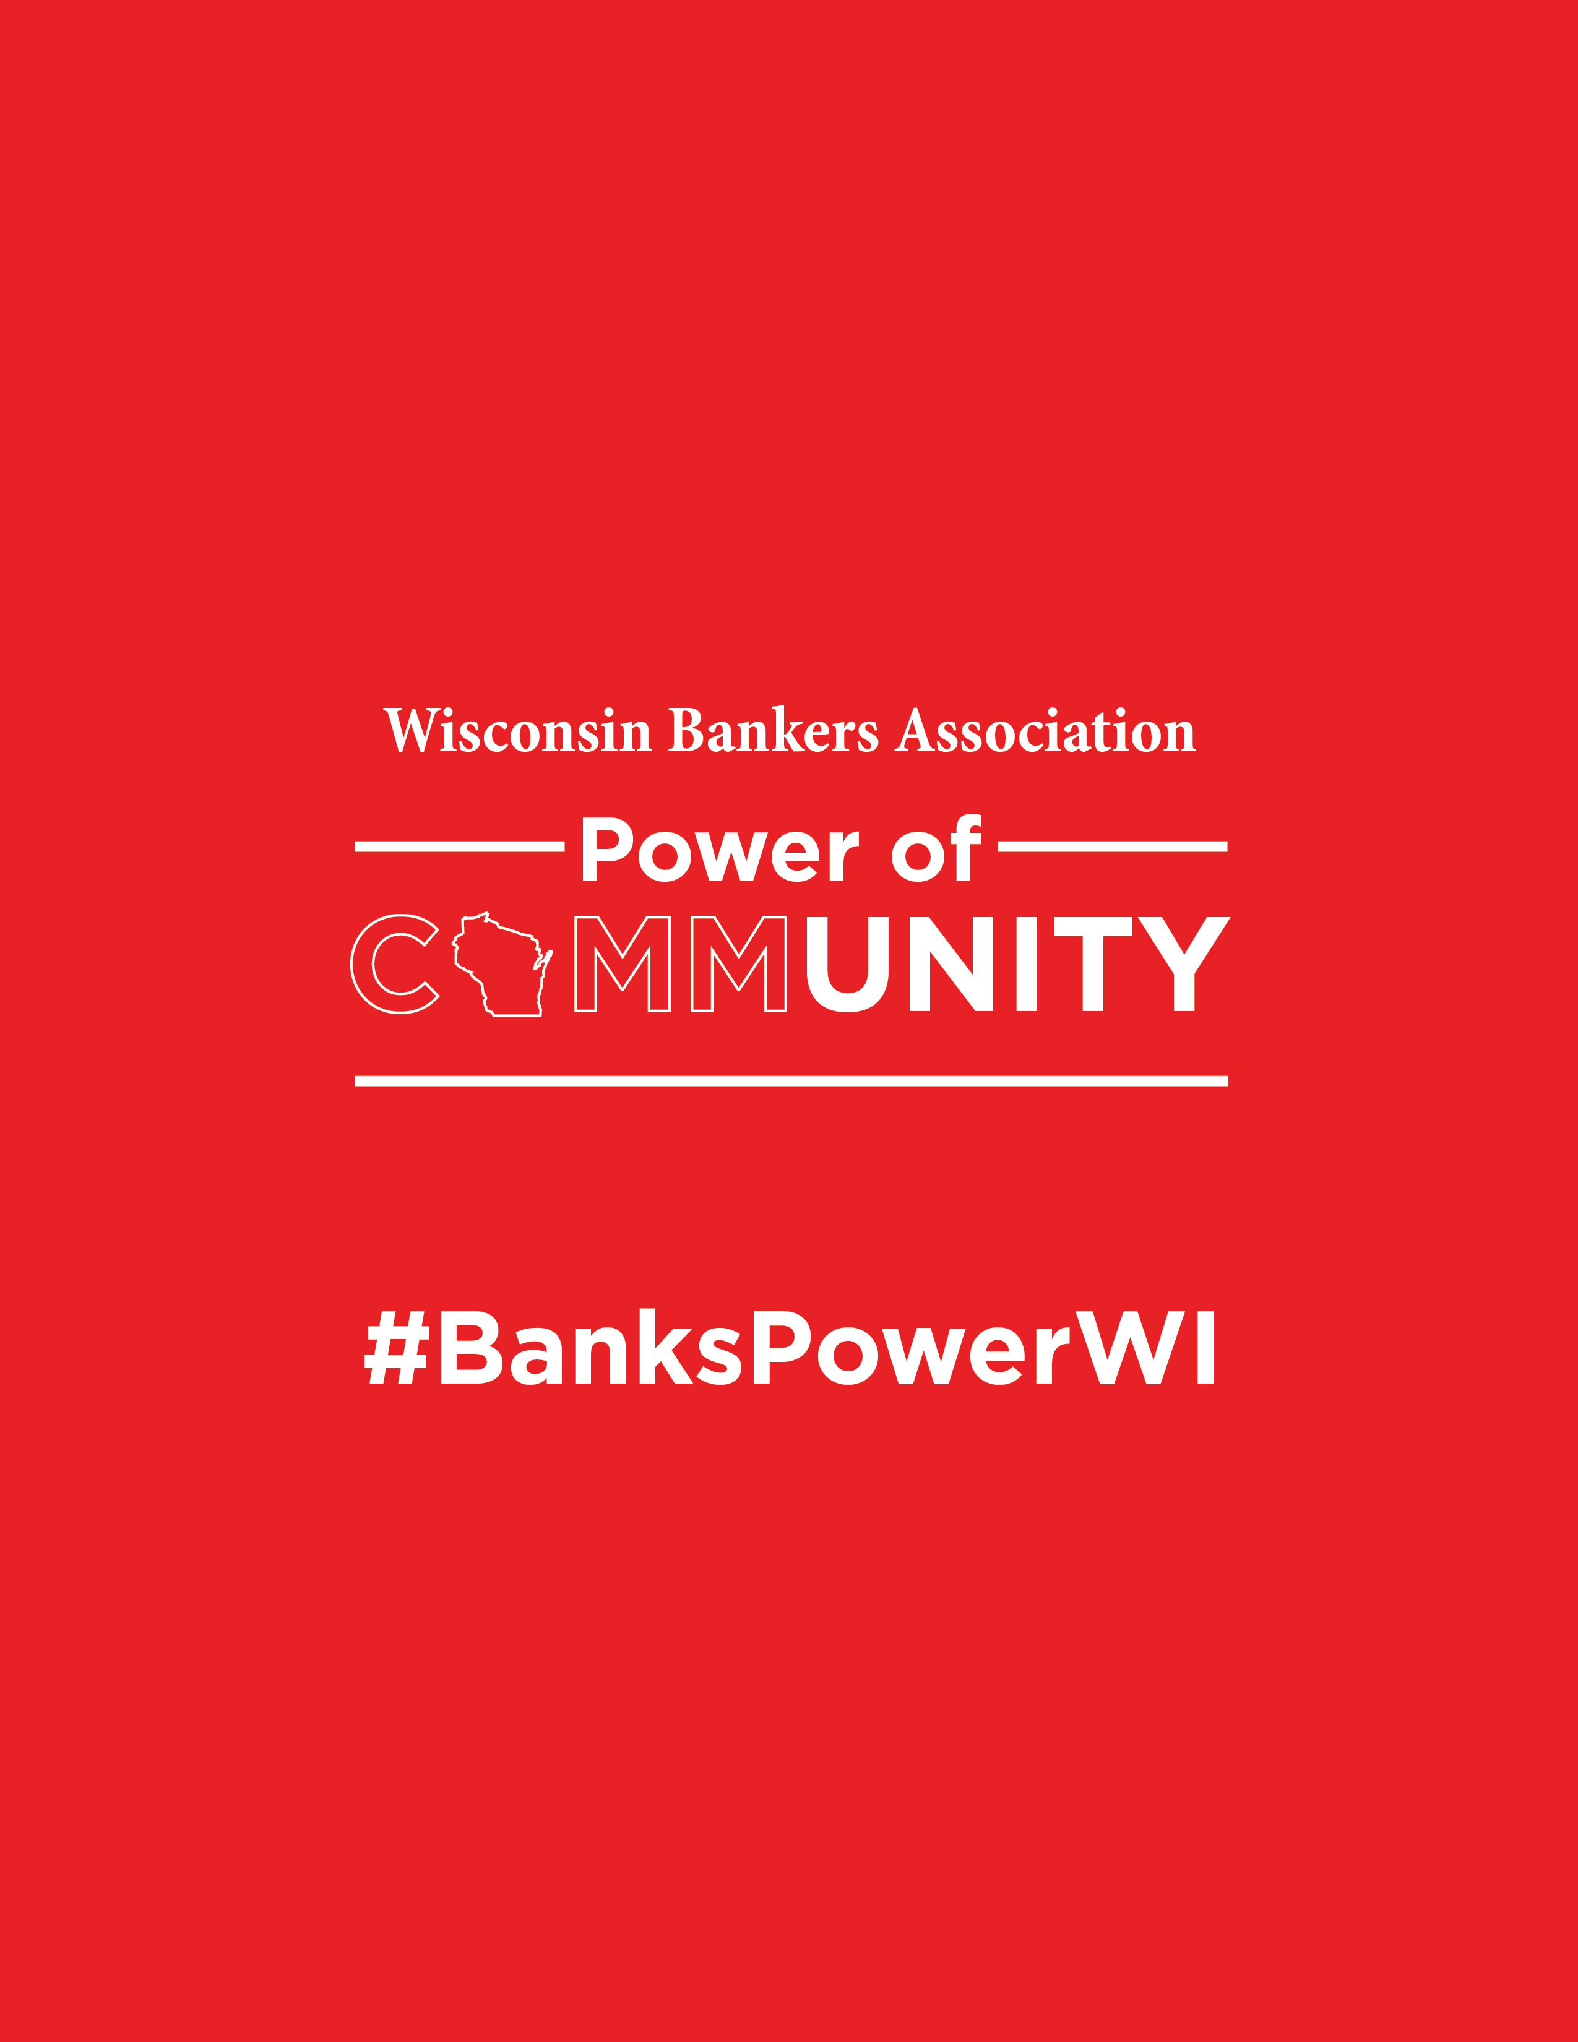

**[INSERT BANK LOGO]**

**QUESTIONS?**

Contact [INSERT BANKER NAME]

